Brian Engel

Client Communication and Recommendations

The UI Wireframe has more details on the buttons and navigation of the app and should be viewed while reading this.

The initial screen in the UI wireframe is the login page. The function that this page serves is to login or create an account if they don’t have one. Pressing the login button will take you to the main page of the app if the credentials are valid. I designed this to be just like virtually every other login screen around, so that the user will already know how to use it. I did include an option for either username or email address, as it did come up in one of the interviews to not have to make up a random username that will be easily forgotten.

The next screen is the main page of the app. It serves the function of displaying easy to read displays of the data and navigation buttons to change how and what data is viewed. The header is for user and account information and logging out. The bottom buttons allow for different ways to view the data. The breadcrumb trail is for backward navigation, and clicking on the buttons in the main section will navigate you to the specific information for that button. The hamburger menu also allows for maintenance of the folders and sensors. The design is meant to keep a large number of sensors organized and be able to tell at a glance if there are any problem areas. This is done with the color-coding system and icons. I came up with this idea while talking with a potential user about how to make a problem area really stick out.

This next screen is a demonstration of if you clicked Back Yard folder on the main screen. I just wanted to show the updated breadcrumb trail and Back Yard folder becoming the top level folder. The breadcrumb trail was added after one of my interviews and it became clear that I hadn’t implemented any sort of backward navigation. It is a simple and uncluttered approach to solving that problem.

The next screen would appear if you clicked Tree 3 sensor in the Back Yard folder. I wanted to demonstrate the updated breadcrumb trail and Tree 3 Sensor folder becoming the top level and being able to see the condition of moisture and nitrogen levels. It also demonstrates what the hamburger menu will contain for a sensor, since that is different from the folder hamburger menu.

This next screen is for the graph for tree 3. It shows the updated color on the bottom buttons to indicate what tab you are on. There are no new navigational buttons on this page and is primarily used for displaying data. I only really added this because it seems people really love graphs. Every interview asked for them. I don’t quite understand because with a system like this it only matters what the levels are right now, not yesterday or last week, but it is simple to implement so why not.

The last screen will display when a user clicks either insert new sensor from the hamburger menu on the folder page or update sensor from the hamburger menu on the sensor page. This is the page that benefits the user the most, but no one knew they needed it until I went through a series of questions about how they would set the levels for the sensors. If you are a professional and know what the moisture and nitrogen levels are supposed to be you can choose custom and set it yourself if you want. The problem is almost no one knows what the nitrogen level should be for an apple tree, and whether it’s different from what an orange tree should be. With the dropdown menu you just click on the plant for the specific sensor, and it sets the levels for you.

Adapting the application to be viewed on a digital watch could be done at the expense of limiting the functionality of the application. The first thing I would eliminate is the login screen and figure out a way to automatically log in the user's account. The UI could be changed to just show the sensors that need attention and eliminate the ones that are good. This would help to minimize the needed screen space for the main screens and further eliminate clutter. I would also eliminate the buttons to change in between data views on the bottom of the application. Instead I would possibly put a secondary button next to the primary data button to show the map, and I would leave the charts off altogether. I figure the map would be used more when people are out in the field / yard and would utilize the digital watch option more at this point to find the triggered sensors. The hamburger menu would be gone as well, since maintenance of the sensors and folders would be extremely hard to do on a watch. All this being said, this application isn’t really designed for a digital watch and a hefty tablet or phone is the preferred device, but in a pinch you could locate the correct sensors with a digital watch. The more sensors that are connected though, the less viable this option would be. I think that by focusing on these tasks, having the available options easily accessible, and not needing constant connection by using the last know condition of the sensors adheres to the best practices for wearables (Android, 2024).

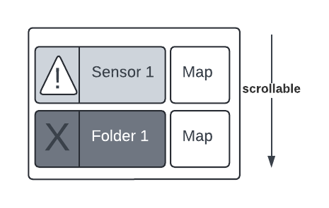

This is what comes to mind for the wearable interface.

Adapting the application to be viewed on a touch-based kiosk could actually be done fairly easily. This time I would keep the login screen since a kiosk is usually a communal device, and we need to make sure we are working with the correct data. Once again, I would get rid of all the bottom buttons, but instead of eliminating or changing the data presentation, I could have all of them on the display at once. I would have the left half of the display as a scrollable list of sensors and folders, since it could be shorter or longer depending on the number of sensors and folders. I would place the graph at the top right of the screen and the map at the bottom right of the screen. I think these would be best in the smaller portions of the screen since they will always have a constant rectangular shape. One thing to consider is security on a device like this. Since it is a communal device, logging out is particularly important to not let unauthorized individuals have access to your information. I would probably enact some sort of auto sign-out after a pause in activity, and reminders on the interface to the user to sign out when finished.

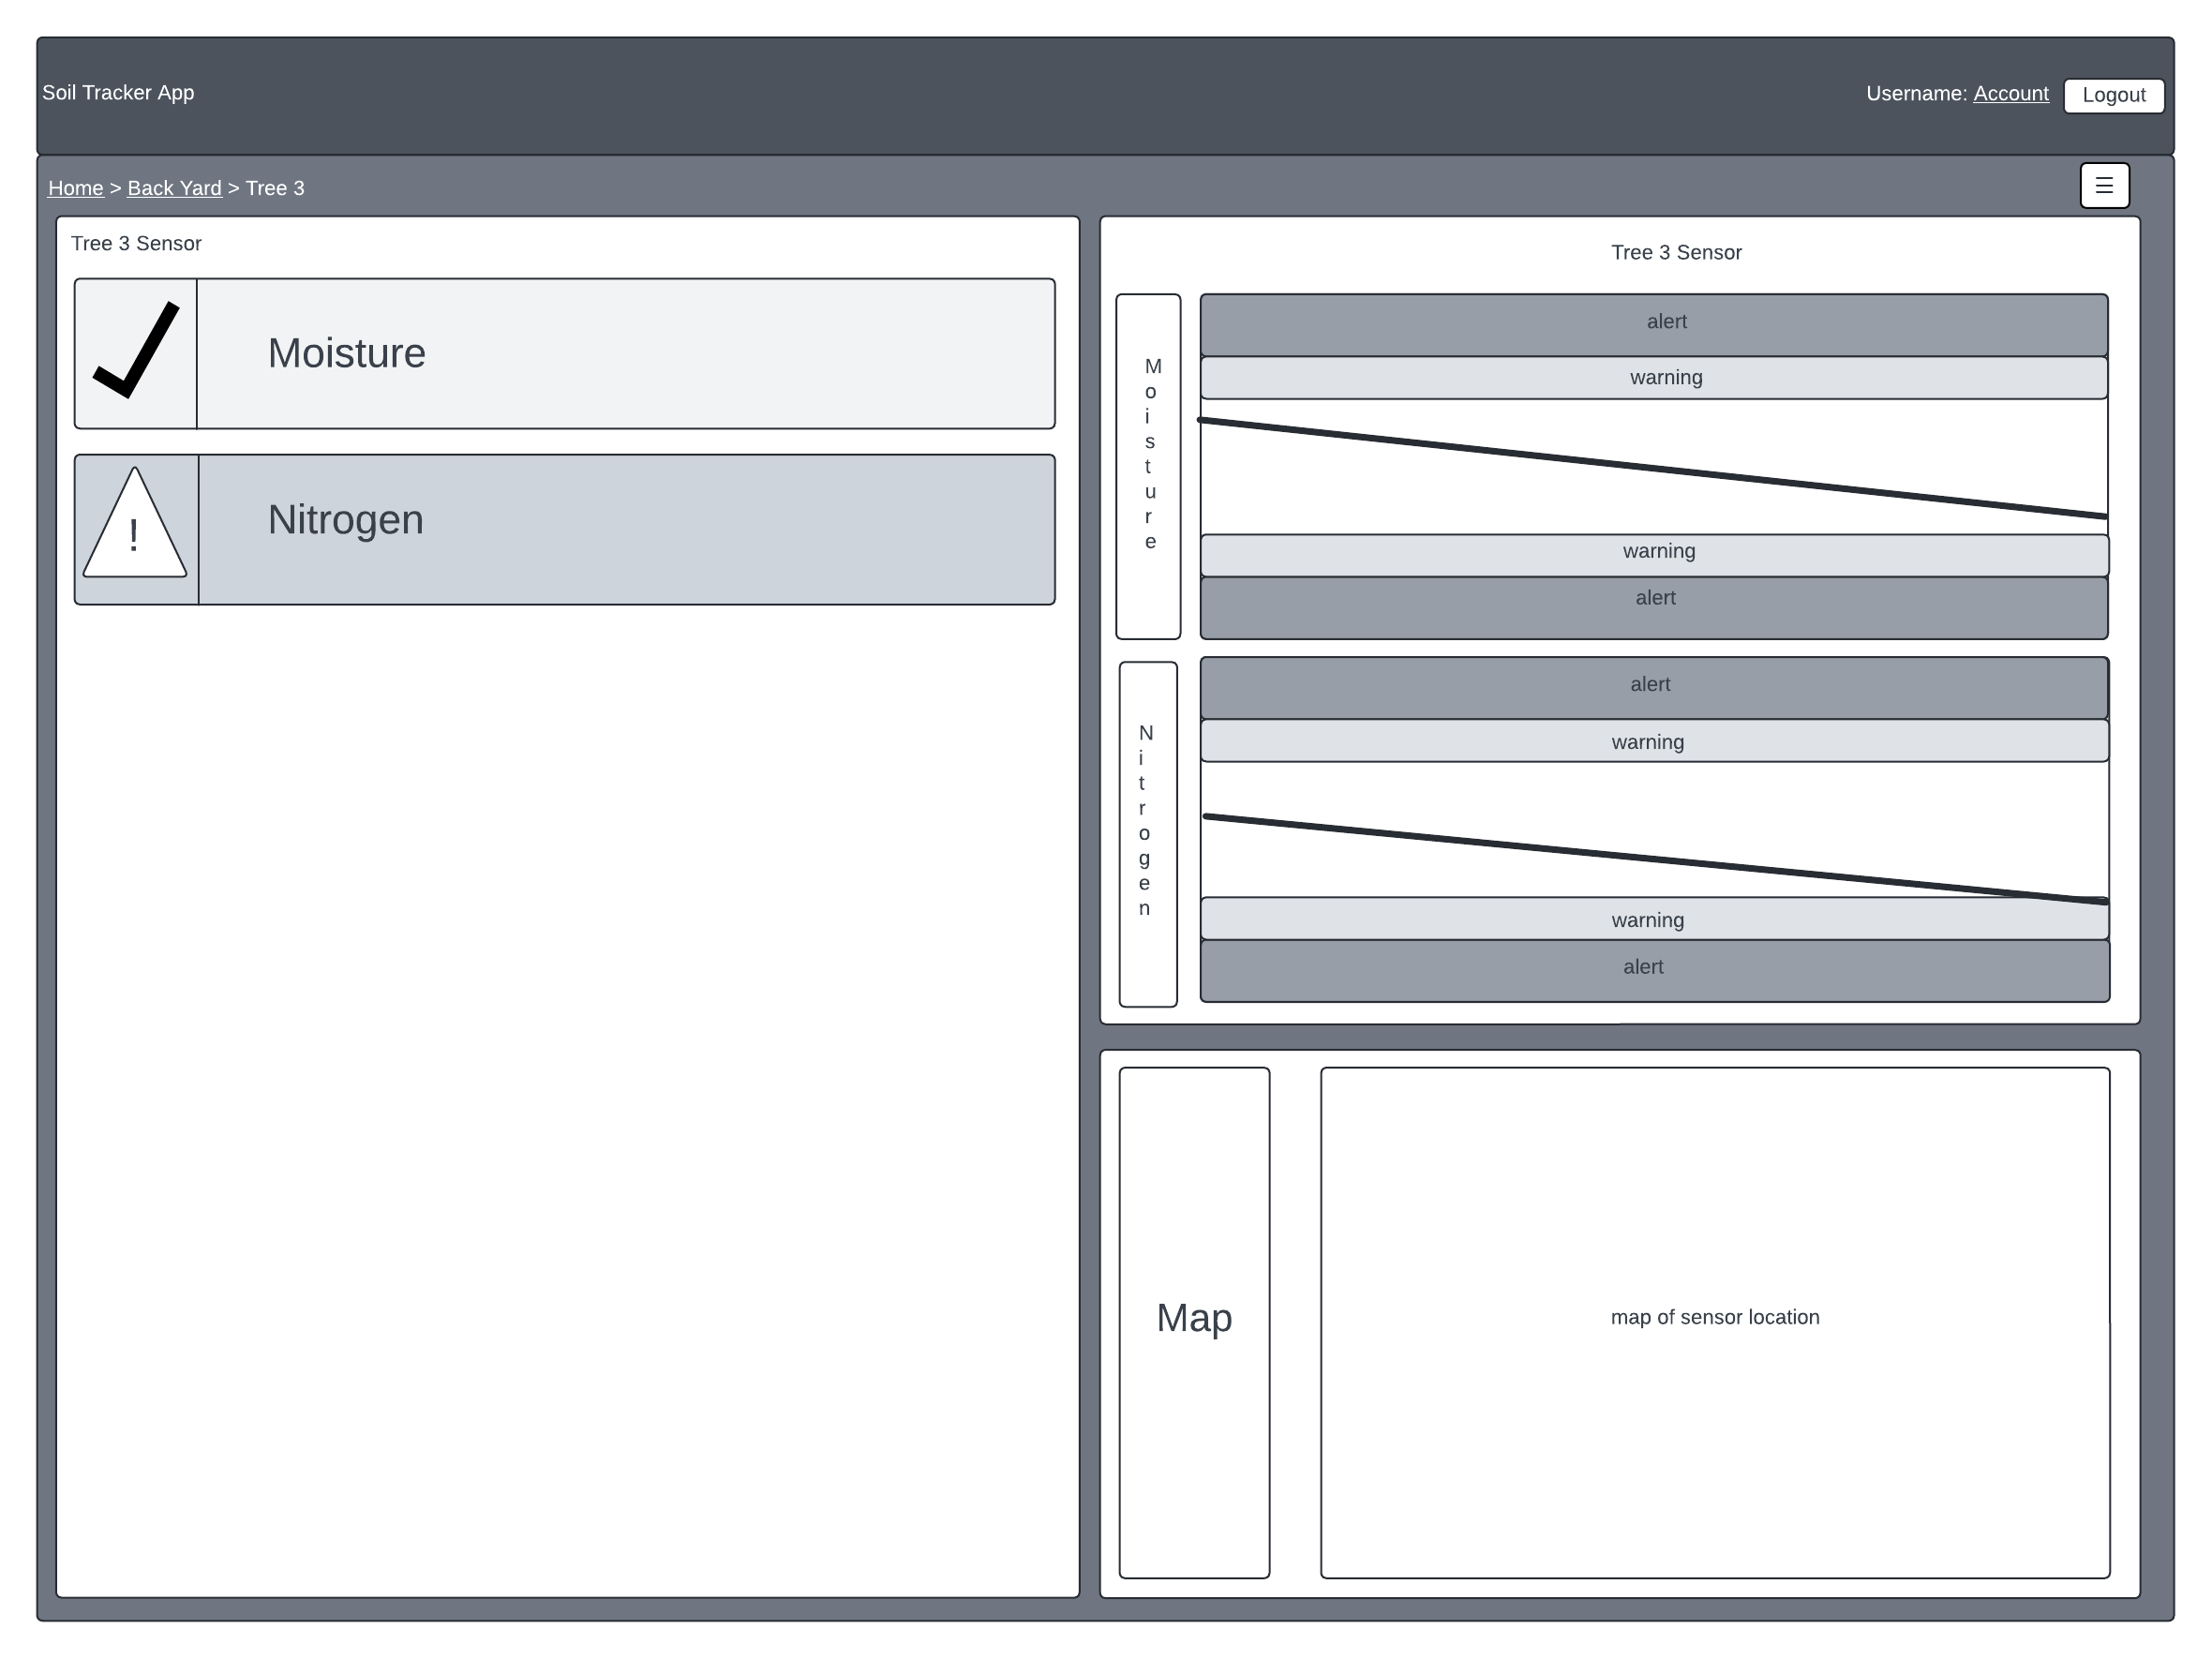

This is what comes to mind for the kiosk interface.

Android Developers. (2024, March 26). Design principles. Android Developers. <https://developer.android.com/design/ui/wear/guides/foundations/design-principles#together>